Retail Sales System – Entity Design and ERD

Task-1: Identify and list all entities
- Store: A place where products are sold and stock is managed.
- Product: The items that the store sells.
- Customer: The people who buy products from the store.
- Order: A purchase made by a customer.
- OrderItem: The products and their quantities in an order.
- Inventory: The number of each product available in the store.

Task-2: Attributes and keys:
Entity-1: Store
Attribute | datatype | PK/FK | Example value
StoreID | String | PK | STR-01
StoreName | String | - | AtoZStore
Location | String | - | Shimoga
ManagerID | String | FK->Employee | MGR-01
ManagerName | String | - | Rahul Sharma

Entity-2: Product
Attribute | Data Type | PK/FK | Example Value
ProductID | String | PK | PROD-01
ProductName | String | - | Rice 5kg
Category | String | - | Groceries
BasePrice | Decimal | - | 450.00
MRP | Decimal | - | 650.00

Entity-3: Customer
Attribute | Data Type | PK/FK | Example Value
CustomerID | String | PK | CUST-01
FirstName | String | - | John
LastName | String | - | Wick
Email | String | - | boogiman@email.com
Phone no. | String | - | 9900112233

Entity-4: Order
Attribute | Data Type | PK/FK | Example Value
OrderID | String | PK | ORD-01
CustomerID | String | FK->Customer | CUST-01
StoreID | String | FK->Store | STR-01
EmployeeID | String | FK->Employee | EMP-01
OrderDate | Date | - | 05-06-2026

Entity-5: OrderItem
Attribute | Data Type | PK/FK | Example Value
OrderItemID | String | PK | LINE-01
OrderID | String | FK->Order | ORD-01
ProductID | String | FK->Product | PROD-02
Quantity | Integer | - | 2
UnitPrice | Decimal | - | 150.00
Subtotal | Decimal | - | 300.00

Entity-6: Inventory
Attribute | Data Type | PK/FK | Example Value
InventoryID | String | PK | INV-01
StoreID | String | FK->Store | STR-01
ProductID | String | FK->Product | PROD-01
StockQuantity | Integer | - | 150
LastRestockedDate | date | - | 20-02-2026

Task 3: Relationship Descriptions – Retail Sales System
- Store and Inventory(1:M)
One Store can have many Inventory records, but each inventory record belongs to one store.
- Product and Inventory(1:M)
One Product can appear in many inventory records, but each inventory record refers to one product.
- Store and Product(M:M)
A Store can sell many Products, and a Product can be sold in many stores. This M:M relationship is resolved by the Inventory junction table.
- Customer and Order(1:M)
One Customer can place many Orders, but each order belongs to one customer.
- Store and Order(1:M)
One Store can process many Orders, but each order is placed at one store.
- Order and OrderItem(1:M)
One Order can contain many OrderItems, but each order item belongs to one order.
- Product and OrderItem(1:M)
One Product can appear in many OrderItems, but each order item refers to one product.
- Order and Product(M:M)
An Order can contain many Products, and a Product can appear in many orders. This M:M relationship is resolved by the OrderItem junction table.
Task 4 – ERD Diagram:
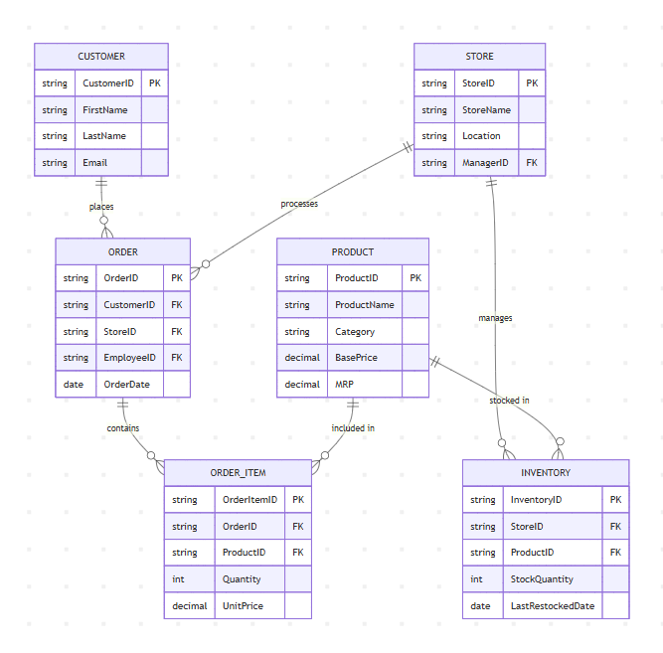
Task 5: Business Questions
1. Which product sold the most units this month?
Use Product, OrderItem, and Order tables. Check this month’s orders and add the quantities sold for each product. The product with the highest total is the answer.
2. What is the inventory level of Rice 5kg at the Bengaluru store?
Use Inventory, Product, and Store tables. Find Rice 5kg at the Bengaluru store and check its stock quantity.
3. Which customer spent the most money in the last 30 days?
Use Customer, Order, and OrderItem tables. Look at orders from the last 30 days and add the amount spent by each customer. The customer with the highest total spent is the answer.
- M:M

